Co-Curricular Assessment

Red Lake Nation College has defined “co-curricular programming” as extra-curricular activities, programs and learning experiences that complement the academic curriculum and enhance the mission of the Red Lake Nation College. Co-curricular activities have department-specific objectives and are embedded within the academic course structure.

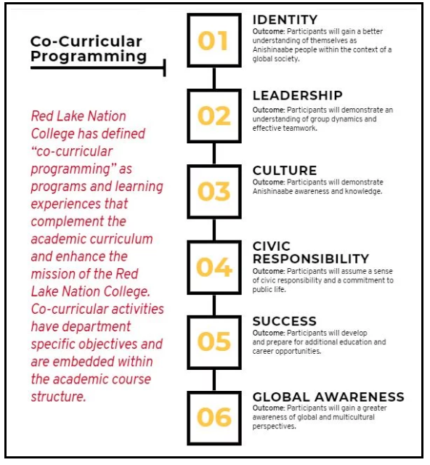

Academics | Student Success | Continuing Education/Extension
Civic Responsibility  What is assessed?  Paritcipation in events that benefit the community? | Leadership  What is assessed?  Membership in Student Government and other student organizations | Culture  What is assessed?  Participation in events and workshops exploring Anishinaabe culture, art, and history.
Global Awareness  What is assessed?  Participant understanding of global and cultural perspectives. | Success  What is assessed?  Participation in the Success Mentor Program, tutoring services, and career and transfer planning. | Identity  What is assessed?  Cultural events that focus on the exploration of one’s identity.

Event Information
Name of Event:
Date of Event:
Facilitator:
Facilitator Credentials:
Purpose of Learning Experience:
How does it contribute to the mission of the College?
Which co-curricular theme do you intend for the learning experience to impact? (Identity, Leadership, Culture, Civic Responsibility, or Success)
Measurable Learning Outcomes/Instruments
Which learning outcome are you measuring?
What specific, observable, or measurable skill or knowledge will students be able to demonstrate as a result of this event? Example: As a result of participating in the Resume Writing Workshop, students will create an updated resume.
Select the Assessment Method
How many students participated in the learning experience?
What assessment method will you use to determine whether or not students achieved your stated learning outcome?
What instrument will you use to measure this achievement? (Examples: pre and post-tests, final results such as a resume)
Analyze and Interpret the Results Following the Event
What are the results?
What themes emerged?
Did the learning experience do what it was intended to do?
Report and Use Results
How will you use these results to guide future events?
How could this or a similar learning experience be enhanced for the future?

